**SUMMARY**

A total of 82/197 (41%) of students registered in the Experimental Medicine Program (ExMed) in May/June 2021 completed the survey. About three quarters (74%) of responders answered all the questions posed in the survey. A majority of the respondents were PhD (55%) and domestic (85%) students.

Generally, students have a neutral attitude towards the program and the university. Most of the students find the tuition costs to be only somewhat reasonable and similarly, are only somewhat satisfied with the ExMed Program. Particularly, most PhD students indicate feeling somewhat satisfied and ambivalent towards the program. Furthermore, it is concerning that a large percentage (39%) of the responders would not recommend ExMed to other students considering graduate studies. This is particularly the sentiment of the PhD (n=21, 55.3%) and domestic students in the program (n=26, 68.4%). This highlights an urgent need to further investigate what aspects or lack thereof in the program are rendering the students to feel only minimally satisfied with their experiences in ExMed.

Fortunately, the majority of responders (n=33/65, 50.8%) believe that finding information about the program was somewhat or extremely easy, and this may be attributed to the updates and improvements made to the program website. Also, most students (65%) answered being able to register in their desired courses suggesting that ExMed is currently offering the right number of seats for each course. Interestingly, only a small portion (n=14/82, 17%) of students are opting to take courses outside of the program even though this is an option available to all students. At the same time the vast majority (76%) of students indicate that they desire more options for elective courses within the program. Future steps can include following-up on this survey with an initiative to help elucidate the types of courses students are interested in taking through the program (e.g., outcomes research, bioinformatics, public health, health economics, etc.). On the other hand, students are mostly satisfied with the courses they have taken, indicating the good quality of courses currently available through the program.

Moreover, students are overall satisfied with their supervisors. They indicate receiving the necessary support and feeling comfortable speaking to and discussing issues with their supervisors. They also indicate receiving feedback on their work and projects. Overall, it seems students have healthy and professional relationships with their supervisors.

Assessing funding, a good proportion (77%) of students receive adequate funding ($20,000-$30,000) each year. There are however a few students (n=4) who indicated that they received less than $18,000/year and this is the minimum required. Not surprisingly, international students (n=15) responded worrying more often about funding when compared to domestic students; this is possibly due to higher tuition costs and living expenses in Vancouver.

When assessing the impact of COVID-19, most students (n=47, 81%) indicated that the pandemic had affected their overall wellbeing, but did not have much of an effect on their academics and education (n=19, 37%). When further delving into wellbeing and mental health, students overall indicated feeling confident in approaching setbacks (n=28, 52%) and capable of completing the program successfully (n=35, 61%). Furthermore, students in the program most commonly stated knowing about the following resources: UBC Counselling, UBC Health Services and Library Research Commons. They also indicated feeling satisfied with these services except for UBC Counselling.

When exploring the issue of bullying/harassment, of the 82 responders, 25 (31%) chose not to indicate an answer to the questions posed in this subject area. Nine students reported having experienced bullying/harassment from faculty/non-faculty members, while 9 reported generally experiencing bullying/harassment of which only 5 notified someone in a leadership position. Sadly, only 1 of the 10 responders indicated feeling satisfied with the way the incident was resolved. Based on these results, it is clear that a more effective reporting system needs to be implemented immediately. As well, further effort needs to be employed to devise an effective resolution system to address bullying/harassment in the program.

In conclusion, this survey has provided insight into some of the issues students face in the department of ExMed. Increased efforts need to be taken to address the problems discussed in this report. Further details and graphical summaries are presented in the remainder of this report.

**DEMOGRAPHICS**

**Survey Completion rate**

41% (82/197) of registered Experimental Medicine students completed the survey. Among responders, 74.4% answered all the questions, while 80.8% finished over half of the questions.

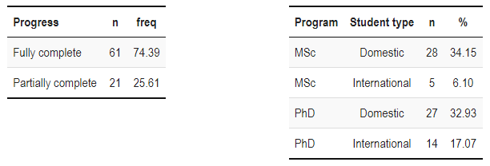

**Student Program and Status**

There are more PhD students (55.4%) than MSc students (44.6%) that responded to the survey.

Domestic students (84.8%) composed the majority of the student body, but the Experimental Medicine program also has a high percentage of international students (15.2%) working on their MSc or PhD degrees.

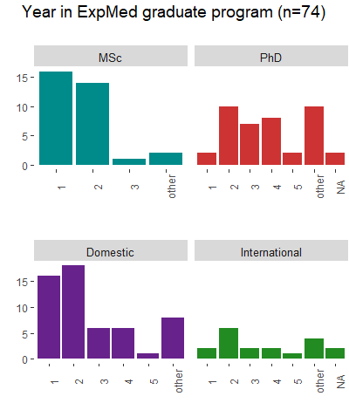

**Student Program Progress and Start Date**

Most MSc responders are in their first or second year of the program, and all started their program in 2018 or later. Most PhD responders are in their second, third, or fourth year of the program. Their program starting date is also evenly distributed from 2015 to 2020, with a few outliers. However, this data did not account for MSc students transferring to the PhD program during their first or second year of study, which could alter the demographic of first year MSc/PhD students.

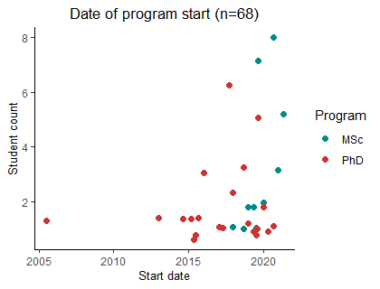

**PROGRAM FEEDBACK**

**How reasonable or unreasonable is the tuition cost at this university?**

As depicted in the leftmost graph, the majority of MSc (n=17) and PhD (n=17) students find the tuition to be reasonable (ranging from somewhat reasonable to somewhat unreasonable). In the right graph, we find that most domestic (n=25) students believe the tuition costs to be somewhat reasonable.

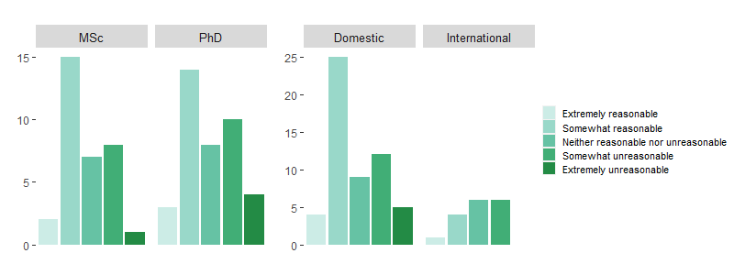

**Overall, how satisfied or dissatisfied are you with the ExMed Program?**

Most MSc students (n=15) appear to be somewhat satisfied with the program, whereas most PhD students seem to be divided between feeling somewhat satisfied (n=13) and neither satisfied nor dissatisfied (n=13). The distributions stratifying satisfaction level by domestic status follows a similar trend to that comparing program level.

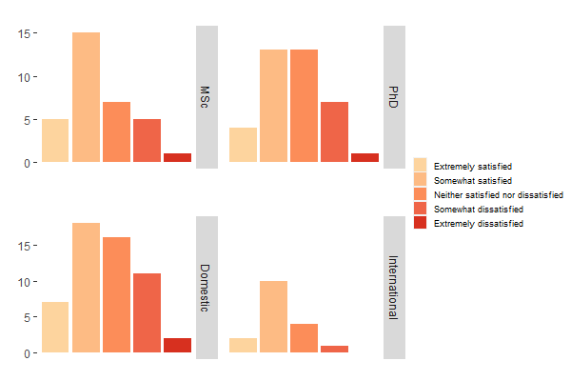

**How likely are you to recommend this program to students considering graduate school options?**

Most students would not recommend the program (39%) to other students considering graduate studies or have no opinion (34%) at this point. Interestingly, when we stratify by program level, the majority of PhD (n=21) students responded as not likely to recommend the program. This is particularly the sentiment of domestic students.

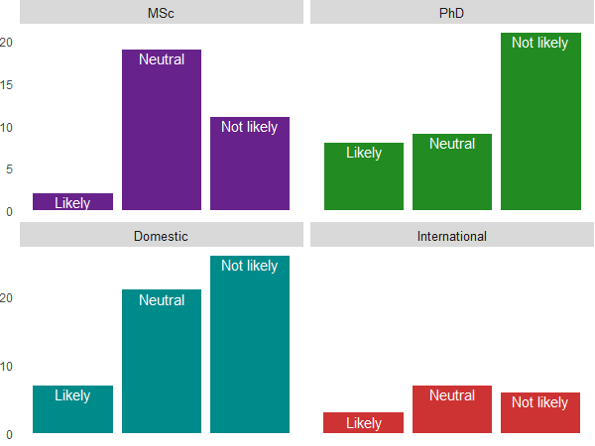

A separate question asked, “How likely were to you to recommend the program to someone else” and scored them from 1 (Completely unlikely) to 10 (Completely likely). The median value was lower for PhD (6) compared to MSc students (7). This difference was not significant (*P*=0.71).

Around half of the responders (51.2%) attended the ExMed Orientation. There were 28% of responders who explicitly indicated that they did not attend their orientation.

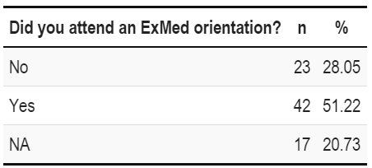

**How easy has it been to find information about processes and requirements of the program?**

The vast majority of responders (n=33) answered that finding information about the program was somewhat or extremely easy. However, 12/65 (18.5%) responders indicated that finding relevant information was somewhat difficult.

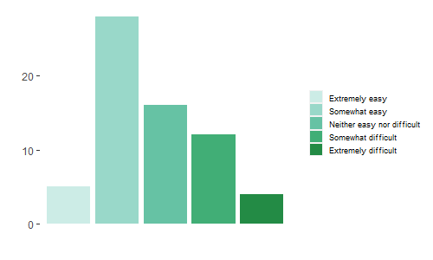

Most students took courses offered by the Faculty of Medicine - this of course includes the required courses (MEDI 501, MEDI 502 and MEDI 549 (thesis course)). Approximately 9% of courses listed by responders were not listed in our survey.

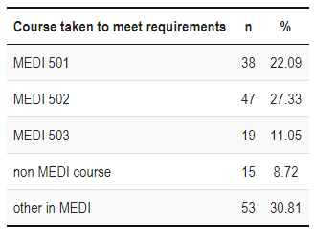

Students (65%) mostly indicated that they were able to register in their desired courses. This suggests that the program is offering an adequate number of seats for each course. Most students also opt to sign up for MEDI courses, with only few students (n=14) enrolling in courses outside the program.

**What was your overall satisfaction with the courses you took?**

As seen previously, answers range mostly between extremely satisfied and neither satisfied nor dissatisfied. Few responders (n=7) indicated that they were somewhat dissatisfied or extremely dissatisfied with the courses they have taken.

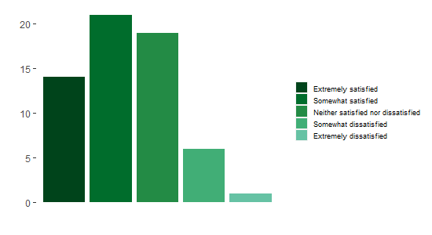

The vast majority of students (76%) indicated that they desire more options for elective courses within the department. It may be worthwhile, following-up with an initiative to elucidate what types of courses students are interested in (e.g., outcomes research, bioinformatics, public health, health economics, etc.).

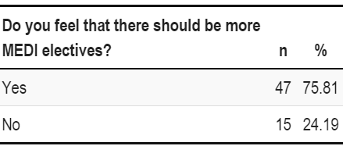

**We are interested in hearing about your relationships with your supervisor?**

Fortunately, most students responded having a healthy relationship with their supervisors overall. They mostly indicated being supported and receiving feedback on their projects. They also responded feeling comfortable speaking and bringing up issues that arise with their supervisor.

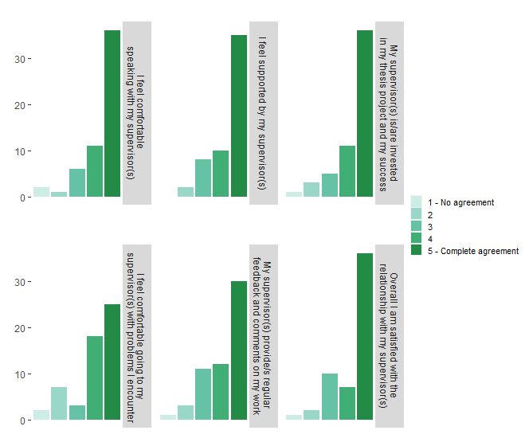

**What average range of funding (CAD$) have you been receiving considering external funds combined?**

Nearly half (43.9%) of students received $20k-30k/year. What was concerning is that some MSc (n=4) reported receiving less than $18k/year, as MSc students should receive a minimum funding of 18k/year.

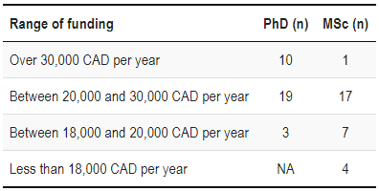

**How often do you worry about funding/finacial support for your studies and living?**

International students tended to worry more often about funding compared to domestic ones, possibly because of higher tuition costs.

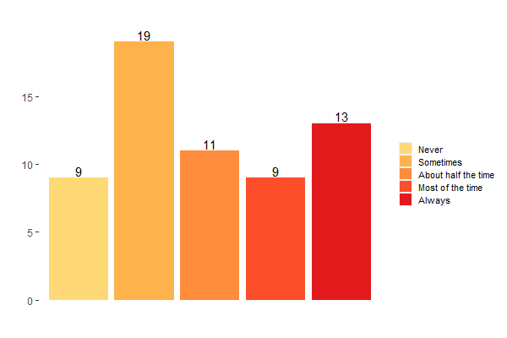

**To which funding opportunities have you applied to?**

The most common funding opportunities applied to were Faculty of Medicine graduate awards and CGS-M/CGS-D scholarships.

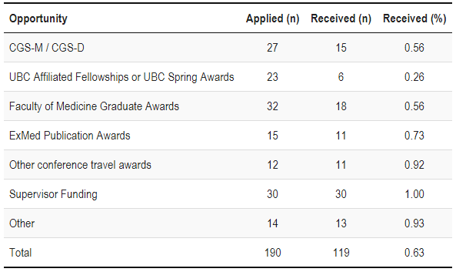

**IMPACT OF COVID-19, WELLBEING AND RESOURCES**

**The COVID-19 Pandemic**

Most students stated that the pandemic has affected their overall wellbeing. However, most students reported that their academic and education has not been affected by the pandemic too much.

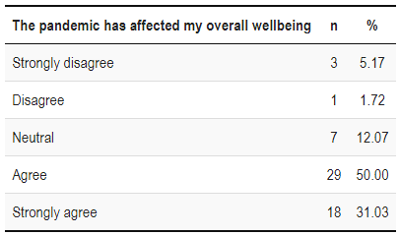

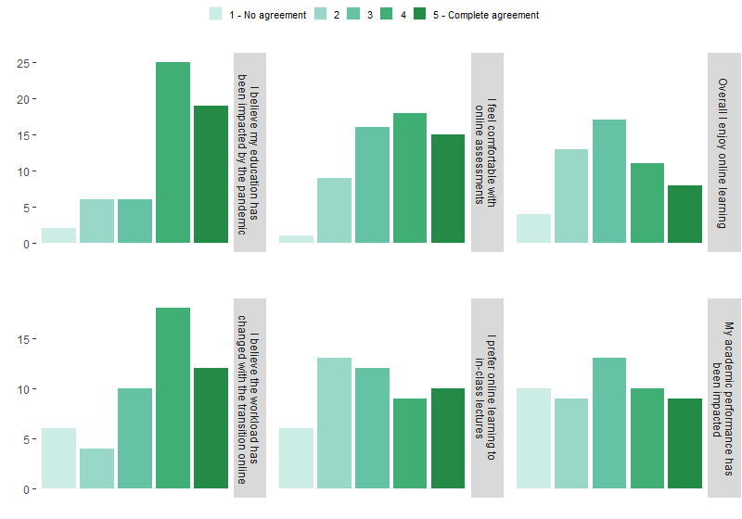

**Wellbeing, Mental Health, and Academic Resources**

The top three resources which are most known by ExMed students are UBC Counselling, UBC health services, and Library research commons.

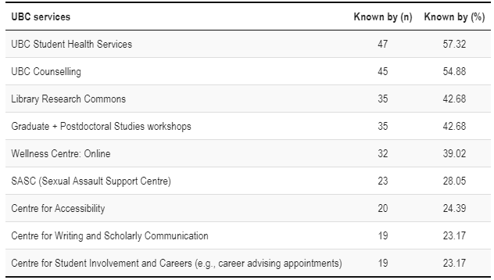

With these services, the majority of users of satisfied, except for UBC Counselling.

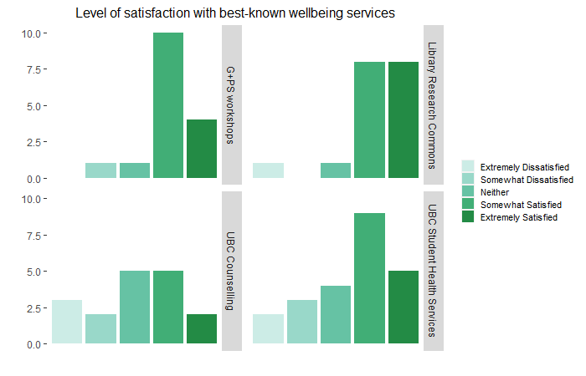

**How are you doing in the program? How are you feeling?**

Overall, students felt confident in approaching setbacks and felt capable to complete the program successfully.

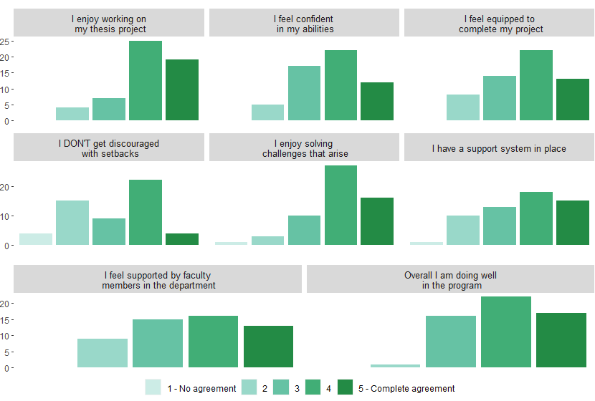

**BULLYING AND HARASSMENT**

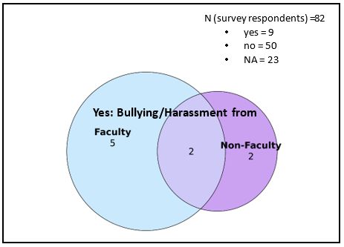

**Figure: Bullying/harassment.** N=82 of which 9 responded they had experienced bullying/harassment by a faculty and/or non-faculty ExMed member, 50 responded they hadn’t, and 23 did not indicate an answer.

It is interesting that while only 9 people report having experienced bullying/harassment from faculty/non-faculty members, 17 report having experienced bullying/harassment, of which only 5 notified someone in a leadership position. Of the 10 students that indicated their satisfaction with the resolution of the incident, only 1 was satisfied. These results, together with the fact that 28% of survey responders did not disclose answers about bullying/harassment by ExMed faculty or non-faculty members, suggest the need for a better reporting system as well as a resolution system regarding bullying and harassment in the program.

